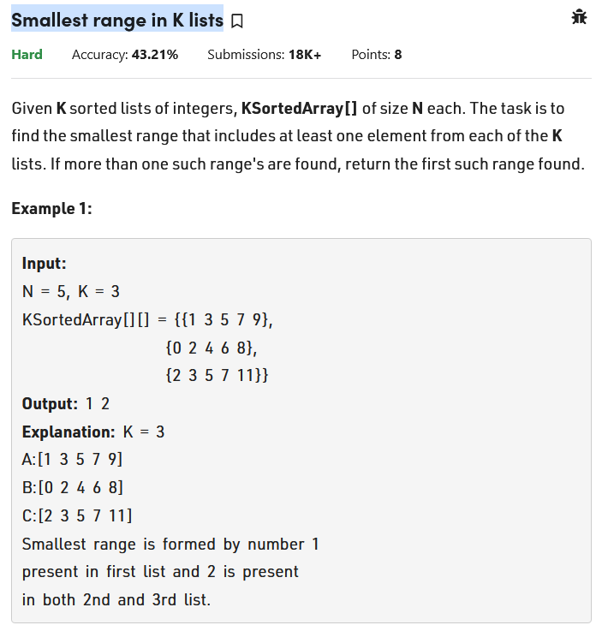

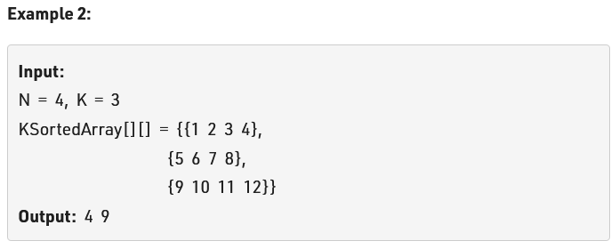

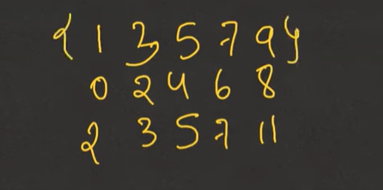

See consider this is our range. We need to tell range from low to high that contain at least 1 element from the all the range given of size 5.

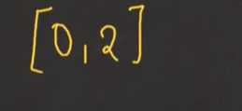

Consider this range taken. Yes, it contains all the list in the range. Also, the above range both low and high is inclusive.

Now logic:

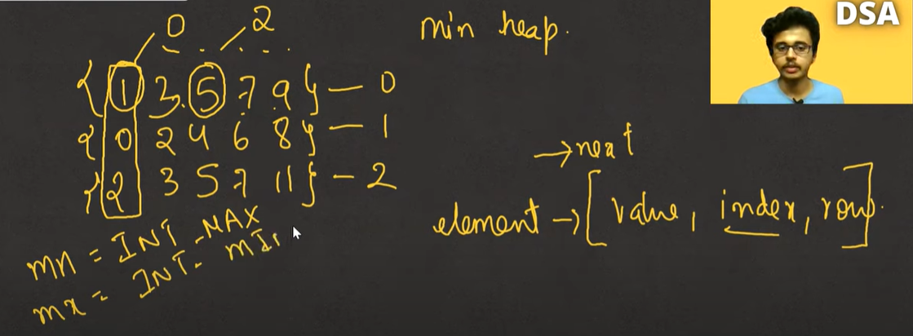

See just like earlier problem merge list we will also take the three value put them on the list heap and try to find the range from them.

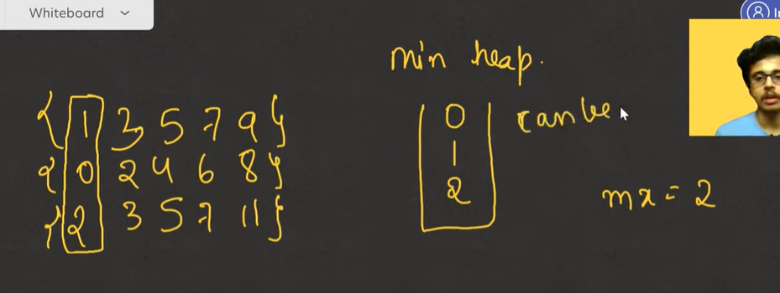

See will take the first element and put them in the heap. then we take a mx variable and will store a when putting variable in heap as max. then we will pop the min element from heap and that will give the range. See in above array the min and max in all the list is 0 and 11. this will be our worst range. Current range though is 0, 2.see we don’t know that this is smallest or not. We will continue this till we find the min range. See for the next element to be inserted we need to pop the min that is 0 from heap and then insert.

Here same logic take the first .see now take the min pop it and then take the same array and push it next min

Now the range would be 4-9. this continue till

Code in leetcode: see in leetcode problem size of array is not equal.

Sol:

<https://ideone.com/6PK6n9>

comparator:

<https://www.geeksforgeeks.org/comparator-class-in-c-with-examples/#:~:text=Comparator%20Classes%20are%20used%20to,between%20data%20can%20be%20made>.